**LED_Sequence V3**

**Dev name: Arafa Arafa**

**Description:**

**Led sequence system include 4 leds and two buttons to control them , button for control turned leds and another button for blinking modes Idle state of system all leds off with pressing button will turn on each led and start blinking depend on certain mode and timer control the timing system of blinking.**

**Mode_1 [t_on =100, t_off = 900]**

**Mode_2 [t_on =200, t_off = 800]**

**Mode_3 [t_on =300, t_off = 700]**

**Mode_4 [t_on =500, t_off = 500]**

**Mode_5 [t_on =800, t_off = 200]**

**There are diagrams to describe the system.**

Figure Layer architecture

Figure flow chart

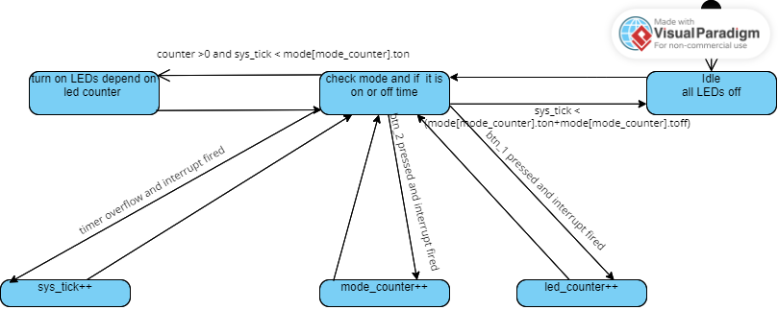

Figure State machine